TRIBHUVAN UNIVERSITY

**PATAN MULTIPLE CAMPUS**

PATAN DHOKA, LALITPUR

**DIGITAL LOGIC (BIT 103)**

**LAB 5**

|  |  |
| --- | --- |
| **SUBMITTED BY** | **SUBMITTED TO** |
|  |  |
| NAME: SURESH DAHAL | JYOTI PRAKASH CHAUDHARY |
| CLASS: BIT – I / I |  |
| ROLL NO: 23 | ………………………… |
| DATE: 2080/12/13 | CHECKED BY |

**TITLE: REALIZE THE GIVEN BOOLEAN FUNCTION F=W’X’YZ+W’XY’Z+WXZ+WX’YZ WITH LOGIC DIAGRAM. SIMPLIFY USING K-MAP AND IMPLEMENT SIMPLIFIED FUNCTION WITH BASIC LOGIC GATES.**

1. **OBJECTIVE**

* To use Karnaugh Map (K-map) to simplify the given Boolean algebra

1. **REQUIREMENTS**
   * 1. Digital Learning Kit and Simulator
     2. 1 OR gate, 3 NOT gates, 4 AND gates
     3. Connecting wires
     4. Interactive / Sequence generator as input
     5. LED as output
2. **THEORY**

* + - 1. **INTRODUCTION**

A Karnaugh map is a graphical method used to simplify Boolean algebra expressions by grouping adjacent cells representing similar input combinations. It offers a visual representation of truth tables, aiding in the minimization of logic functions and the optimization of digital circuits. Karnaugh maps are particularly useful in reducing the number of logic gates required for implementation.

* + - 1. **LOGIC EXPRESSION**

F=W’X’YZ+W’XY’Z+WXZ+WX’YZ

* + - 1. **CIRCUIT DIAGRAM**

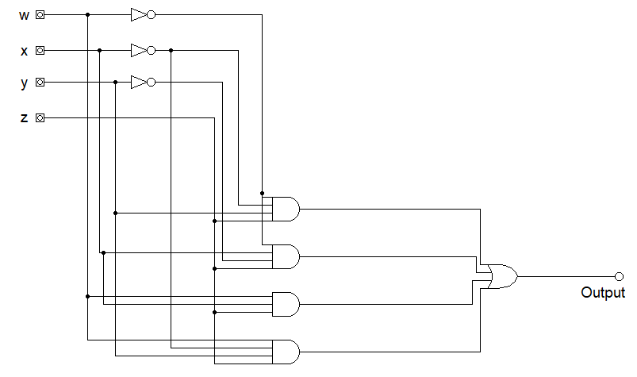

* + - 1. **TRUTH TABLE**

|  |  |  |  |  |
| --- | --- | --- | --- | --- |
| W | X | Y | Z | F (Output) |
| 0 | 0 | 0 | 0 | 0 |
| 0 | 0 | 0 | 1 | 0 |
| 0 | 0 | 1 | 0 | 0 |
| 0 | 0 | 1 | 1 | 1 |
| 0 | 1 | 0 | 0 | 0 |
| 0 | 1 | 0 | 1 | 1 |
| 0 | 1 | 1 | 0 | 0 |
| 0 | 1 | 1 | 1 | 0 |
| 1 | 0 | 0 | 0 | 0 |
| 1 | 0 | 0 | 1 | 0 |
| 1 | 0 | 1 | 0 | 0 |
| 1 | 0 | 1 | 1 | 1 |
| 1 | 1 | 0 | 0 | 0 |
| 1 | 1 | 0 | 1 | 1 |
| 1 | 1 | 1 | 0 | 0 |
| 1 | 1 | 1 | 1 | 1 |

* + - 1. **K-MAP**

**Y’Z’ Y’Z YZ YZ’**

**W’X’**

**WX**

**WX’**

**W’X**

|  |  |  |  |
| --- | --- | --- | --- |
|  |  | **1** |  |
|  | **1** |  |  |
|  | **1** | **1** |  |
|  |  | **1** |  |

**SIMPLIFIED LOGIC EXPRESSION**

F=XY’Z+WYZ+X’YZ

**CIRCUIT DIAGRAM OF SIMPLIFIED EXPRESSION**

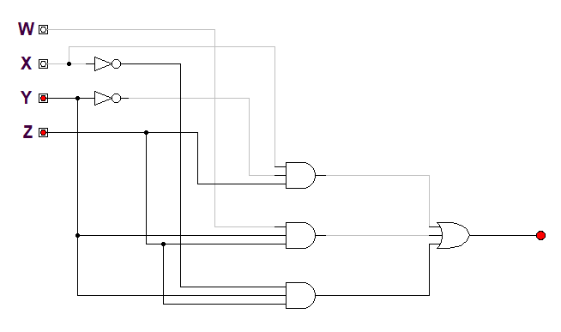

**TRUTH TABLE OF SIMPLIFIED EXPRESSION**

|  |  |  |  |  |
| --- | --- | --- | --- | --- |
| W | X | Y | Z | F (Output) |
| 0 | 0 | 0 | 0 | 0 |
| 0 | 0 | 0 | 1 | 0 |
| 0 | 0 | 1 | 0 | 0 |
| 0 | 0 | 1 | 1 | 1 |
| 0 | 1 | 0 | 0 | 0 |
| 0 | 1 | 0 | 1 | 1 |
| 0 | 1 | 1 | 0 | 0 |
| 0 | 1 | 1 | 1 | 0 |
| 1 | 0 | 0 | 0 | 0 |
| 1 | 0 | 0 | 1 | 0 |
| 1 | 0 | 1 | 0 | 0 |
| 1 | 0 | 1 | 1 | 1 |
| 1 | 1 | 0 | 0 | 0 |
| 1 | 1 | 0 | 1 | 1 |
| 1 | 1 | 1 | 0 | 0 |
| 1 | 1 | 1 | 1 | 1 |

1. **CONCLUSION**

Hence, by doing this practical experiment, we have seen the real world benefit of using K-map and how easily it helps us to simplify any Boolean expressions. By creating logic diagram of and truth table of both given as well as simplified expressions, we have verified that the we require less number of gates to create the logic circuit of the simplified function and upon comparison of the output of both complex and simplified circuits, we get same result. So, by using K-map we can get same result while using less gates and less complicated circuit.